**ABSTRACT: We propose an unobtrusive and afford able system called Sleep Mat-e for monitoring the sleep activity and sleep posture of individuals living in residential care facilities. The system uses pressure sensing mat constructed using piezo resistive material to be placed on the sleeping mattress. The sensors detect the distribution of the body pressure on the mat during sleep and we use machine learning technique to analyze collected data and recognize different sleeping postures. The system is also capable of recognising the four major postures Faceup, Facedown}, Right Lateral, and Left Lateral and generates summaries of postures and the activities over a specified period of time. A real-time feedback mechanism is provided through an accompanying smartphone application alerting the users to correct the posture if person is sleeping too close to the edge of the bed and may fall from the bed. Finally, We conducted experiments to recognize the users sleeping posture and proposed method achieved a classification accuracy of around 90\%.**

**Keyword:** *Force-sensing resistor, Sleep posture recognition; Sleep activity; Internet of Things; Machine Learning; Healthcare.*

# Introduction

In New Zealand, the proportion of the total population aged 65 and over is increasing, which is a common trend in countries all around the world. In 2016, 15\% of New Zealand’s population was aged 65 or above, with the percentage estimated to reach 20% by 2032 [Ref.1]. The elderly tend to face higher rates of physical and cognitive decline that can cause aging-related diseases such as dementia and poor mobility. This may prevent them from living independently and they may require monitoring and/or assisted living in residential care facilities.

Adequate, restful sleep is as important to one’s well-being as a healthy diet and regular physical activity. During sleep, the body and brain undergo necessary restorative activities [Ref.2], and inadequate sleep leads to reduced alertness and drowsiness [Ref.3]. In the United States, an estimated of 50 million people have poor sleep quality or have a sleep disorder such as insomnia, sleep apnea, and narcolepsy [Ref.4]. The elderly tend to suffer from poor sleep quality and this has effects on their physical health, cognitive function and overall quality of life [Ref.5]. These effects are more devastating on the elderly due to their physical status and can cause further sleep-related health issues or injuries. Health issues stemming from poor sleep quality include weakened immune system and cardiovascular disease, and improper sleep posture can exacerbate sleep *Apnea*.

Another issue that is prevalent in the elderly population are pressure injuries (PI) which is due to prolonged sleep in a single posture without moving. The effects of PI can be constant pain, loss of mobility, depression, and even death. These effects are more devastating on the elderly due to their physical status and can cause further sleep-related health issues or injuries. Studies have found that sleep issues were more prevalent within the residential care population [Ref.6]. A report into pressure injuries commissioned by the New Zealand Ministry of Health revealed that the prevalence of PI could be reduced if caregivers were more vigilant and took proactive action to prevent PI [Ref.7].

Furthermore, sleep position and posture are said to be major cause of sleep apnea [Ref.8]. Also, researchers have shown that people sleeping in the decubitus position have higher risk of developing subacromial impingement syndrome compared with those who sleep in the supine position [Ref.9]. People sleeping in supine position are more likely to develop the Symptoms of sleep paralysis [Ref.10]. similarly, sleeping on the right side poses a higher risk of development of transient lower esophageal sphincter relaxation, which is a main factor in nocturnal gastroesophageal reflux [Ref.11]. Furthermore, fall during the sleep are a major risk to the elderly resulting in injuries and even death in extreme cases.

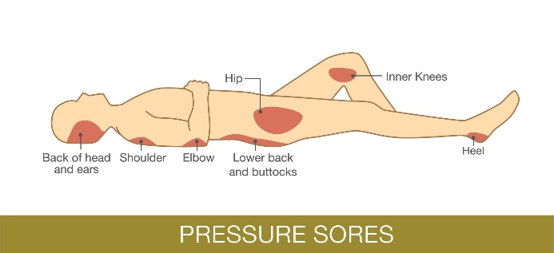

*Figure* *2*: Pressure Sore Face Up [12]

The above risks can be can be reduced if staff actively and regularly monitor the patient. Detecting and monitoring for these symptoms can be challenging and may also require use of extra staff resources. This will lead to increased healthcare costs and can be a significant source of stress for the patient, as well as their family. elderly care facilities were reported to have around 32,000 patients [Ref.13] patients. Funding for Direct Health Boards (DHBs) in 2018 was almost a billion dollars ($983 million) [Ref.14] DHBs is the main contributor to long-term residential care, and this contribution is expected to rise as an increase in the elderly population will require more caregivers at care homes[Ref.15]. In 2018 alone ACC claims were amounting to $200 million for fall-related injuries for the age group of 65 and above [Ref.16].

The challenges, rising costs of care and effects of sleep related issues on the elderly in New Zealand motivates the need for a system that can help medical practitioners and caregivers in residential care monitor their patients more efficiently. We propose an autonomous system that is capable of monitoring sleep posture, sleep activities, and alerting about the expected fall during the sleep. This will help people learn about their sleep habits and improve sleep health by providing feedback on their sleep postures and activities. This will not only reduce the cost and burden on health system but also the provides caregivers and healthcare professionals with sleep related data, so that they could implement preventative measures to reduce and manage the risks of poor sleep as necessary. The healthcare community has also emphasized the need and importance of long-term sleep tracking system to identify trends to help people create personalized sleep goals. The system is used to assess the sleep efficiency (the ratio of total sleep time to time spent in bed), sleep latency (the duration from bedtime to the onset of sleep), insomania, and sleep apnea [Ref.17]. These measures help physicians diagnose sleep-related disorders. A detailed sleep log will assist Health Care Professionals (HCP) to diagnose poor sleep based on the sleep posture distribution during sleep, number of times the bed occupant left the bed and overall time spent in bed.

This paper is organized as follows. The following Section provides the research carried out in the related areas. Our proposed system (Sleep Mat-e) that we want to present in this paper addresses the issues that we have highlighted by providing an unobtrusive, affordable and user-friendly system. This system also provides a sleep log which contains information regarding posture distribution and time spent in bed. The system is also capable of sending various alerts such as fall warning alert. System Architecture and Implementation are discussed in the sections IV and VI respectively.

# Related Work

Sleep is a major part of health and well-being. Researchers have explored diverse techniques on capturing and providing feedback on aspects related to sleep health. Existing sleep monitoring works fall into two broad categories: sleep quality analysis and sleeping posture recognition. The former is to analyze the sleep status, aid in the medical diagnosis of diverse sleep and psychiatric disorders, and serve as an indicator of chronic diseases.

In early studies, most of the research on sleep posture was empirical in nature and it was based mainly data collected interviewing subjects. In recent years, advancements in IoT and sensing modalities have enabled researcher to use these modern techniques to determine the sleeping posture and sleeping patterns. There are numerous solutions available that in one way or another try to quantify the quality of sleep. These solutions use different techniques to acquire data for an individual’s sleep. In a clinical sleep assessment setting, the current ‘gold standard’ in terms for diagnosing sleep disorders and issues is the use of polysomnography (PSG) [Ref.18]. This method involved the measurement of multiple physiological parameters, such as brain activity, blood oxygen level, heart rate, breathing, and leg and eye movements. This requires a lot of sensors and equipment to be physically attached to the patient’s body. Although this method can yield extremely accurate results and insight into a person’s sleep but this is obtrusive and disruptive, expensive and requires monitoring in a highly controlled and unnatural setting. This approach is suitable for medical-supervised evaluations but was infeasible in terms of daily use. A similar device called WatchPAT [Ref.19] is worn on wrist by the subject and it comes with a finger clip which monitors the sleep of the patients within the comfort of their own home and usual sleeping environment. This method is much more informal but it is still intrusive in nature as it requires the device to be worn on wrist tightly thus causing discomfort to the subject and especially if the subject is an elderly person.

There is a plethora of smartphone applications available which are designed to monitor sleep patterns. These applications record sleep and wake up time as well as use phone’s microphone and accelerometer to record snoring, sleep talking and other noises as well as tossing and turning. *Toss 'N' Turn sense* is an Android app that models the sleep and sleep quality without requiring significant changes in people’s behavior. It collects data from seven sensors found in smartphones (an accelerometer, microphone, ambient light sensor, screen proximity sensor, running process, battery state, and display screen state) and predicts the aspects of sleep quality with an accuracy of 81-83% [Ref. 20]. *My Sleep APP* [Ref.21] is smartphone-based application that monitors the sleep and sends alerts to the caregivers if an anomaly is detected. The nature of the anomaly has not been specified in the research. Similarly, ‘*Sleep as Android*’ [Ref.22] and ‘*Runtastic Sleep Better’* [Ref.23] could monitor sleep using sensors built into the phone. The smartphone is required to be placed on the bed for it to work, which means one phone is required for each user. This would not be very economical when there are a lot of patients. Lastly, these require user intervention to start and stop the application which, again, adds more tasks for the caregivers. There is a large number of commercial smartphone applications used for sleep sensing which include: Smart Alarm Clock, SleepBot, MotionX, Sleep Cycle, Sleep Bot, Sleep Cycle, Sleep Tracker, Sleep as Android, Sleep as Android Paid. iSleep [Ref. 24] uses acoustic signals of a smart phone to detect various sleep-related events, such as body movement, couch, and snore.

%Within our context, we considered monitoring methods that required physical contact %with the patient, such as wrist worn devices, to be intrusive. There were also many %alternative solutions that are based on non-intrusive monitoring methods. Smartphone %applications such as

Commercially available wrist worn sleep trackers could also be used for collecting data about the sleep. The popular and widely available trackers are Fitbit Charge2 [Ref. 25] and the Jawbone UP3 [Ref.26]. Thy have only limited functionality and accuracy and can monitor only two or three parameters including movement and heart rate which can be used as the basis for tracking sleep but accuracy of such question is questionable [Ref.27]. In addition, wrist worn devices are battery powered and often require Bluetooth connectivity to gather information. Monitoring sleep still requires the use of a smartphone for storing and analyzing data. This would mean extra tasks for the caregivers to complete within their daily routines. Lastly, wrist worn systems cannot detect sleep posture. Smartwatches are powerful devices in terms of the sensors that are embedded in the device. However, the collection of data is done using the sensors such as accelerometers. Sleep sensing can lower the burden of manual sleep tracking and improve the accuracy of sleep inference at home.

Among the various widely used techniques, pressure sensing and camera based visual data are most common. Different camera systems are used to acquire visual data. Camera based visual technology is another widely used technique used for identifying the postures. [Ref.28] uses a common digital camera to detect falls as well as the postures of elderly people in home environment. They applied the background subtraction to extract the foreground human body and used a projection histogram. They use support vector machine (SVM) algorithm for posture classification and, this combined with floor information, detects a fall.

Researchers in [Ref.29] used 3D camera and Mickrosoft Kinet sensors for analyzing body positions based and monitoring the posture of person in residential care. The authors of [Ref.30] modeled the human body in terms of its constituent body part. For each part, image views from numerous calibrated cameras were combined to build a multi-view Eigen model. The study in [Ref.31] uses bed aligned maps (BAMs) composed of pressure arrays and a single depth camera. Although the BAMs method outperforms previous static sleep pose classification techniques, it does not consider motion. Lee et al. [Ref.32] describes a system using an overhanging Kinect camera over the bed to classify six sleep positions. First they extract body joint positions using Kinect v2 own libraries. They use the relative position of hands and knees with respect to the spine for classification using a parametric approach. The approach requires the patient to not use a blanket. Evaluation and results are not provided. Torres et al. [Ref.33] use a combination of depth and infrared cameras together with a pressure mattress to classify between SAAS positions. Only one scenario with a fixed camera above the bed is used, so alignment problems are not considered. Martinez et al. proposed “BAM” descriptor based on depth information collected from a Microsoft Kinect, which could monitor the sleeping posture and movement data [Ref.34]. This work is further extended to recognize high level activities such as removing bed covers [Ref.34]. Although computer vision-based methods may appear to be suitable for posture recognition and fall detection field, several problems do exist. They are expensive, sensitive to light, and requires installation of cameras. Infringement of personal privacy is a concerning issue for computer vision-based posture recognition systems and elderly people may worry that they are being “watched” by cameras.

Force sensor based solution

Most of the studies involving sleep position tracking

mainly use smart bed-type devices in the form of sensors installed on or near the mattress which include: 1) Inertial Measurement and Unit (IMU) sensor, and 2) wireless sensors (WiFi and RFID), and 3) a dense array of the pressure sensor.

IMU sensor installed on the mattress is used to analyze sleep motion patterns. Hoque et al. proposed a sleep monitoring system based on Wireless Identification and Sensing Platform (WISP) equipped with accelerometers [Ref.36]. The system distinguished four sleep positions by using the y-axis accelerometer readings. MediSense [Ref.37] did not directly estimate sleep positions, but inferred patient’s motion activities (stay still, arm wave, body rotate, and body shake) from noisy bed motions by using z-axis gyroscope readings.

Wi-Sleep [Ref.38] classified a person’s respiration, six sleep positions, and rollovers by leveraging WiFi signals, i.e., channel state information (CSI), from a pair of TX-RX. TagSheet [Ref.39] used passive RFID tags taped under a bed sheet or on the surface of a mattresseson a bedsheet. Passive tags are powered by RF waves from an RFID reader, and they communicate with the reader by backscattering the RF signals. By observing the RF signal variance amongst all tags, the reader is able to construct a coarse-grained grayscale snapshot and TagSheet can analyse the snapshots and can identify six sleep positions and estimate the respiration rate. SMARS [Ref.40] exploits Ambient Radio Signals to recognize sleep stages and assess sleep quality. The key enabler underlying SMARS is a statistical model that accounts for all reflecting and scattering multipaths, allowing an accurate and instantaneous breathing estimation. SMARS is capable of recognizing different sleep stages, including wake, rapid eye movement (REM), and non-REM (NREM). SleepSense [Ref.41] a Doppler radar-based sleep monitoring system, which monitors and classify the sleep-related events by detecting the on-bed movement activities during sleep based on the radar signal, without including sleep-wake classification. The Doppler radar sensor is a specialized radar that can measure target displacement remotely by using the Doppler Effect.

More recently, research has shifted to pressure sensing techniques [4], [8]. An early idea presented by M. P. Toms [Ref.42], describes the use of fluid filled cells between the patient and a support in order to detect motion via pressure fluctuations. Alaziz et al. [Ref.43] suggest to use low-end load cells placed under each bed leg, and classify 27 pre-defined movements by analysing the computed forces.

By designing a pressure sensitive bedsheet with densely deployed textile sensors, they are able to capture the pressure mapping images and recognize different postures using classifiers. Alternatively, dispersed pressure sensors embedded in the mattress can record when changes in body posture occur. This method is unobtrusive and does not interfere in the comfort of users. Also it is a stable medium that is not affected by changes in the environment. Liu et al. [Ref.44] designed a non-invasive pressure-sensitive bedsheet to monitor different sleep postures. The generated high-resolution pressure maps can be further utilized for sleep monitoring.

S. Lokavee et. al. [Ref.45] proposed a sleep monitoring and gesture recognition system for patient based on polysomnography. This sensor pillow system employs a 3x3 sensor array of FSR (force sensing resistor) based on polymer thick film device for classifying and recognizing sleep posture. However, this work is only useful for point-of-care applications. E. J. Pino et. al. [Ref.46] implemented a noninvasive sleep monitoring system using a bed pressure sensor array. The system detects changes in the contact pressure between a subject and the bed and is able to automatically select the sensor with the best respiratory signal, determine the respiratory rate, count number of sleep apneas, and count body position changes through the night. This work is similar to our approach except the smaller sensing area of 300 mm × 900 mm. However, they did not distinguish what posture a person is lying in.

L. Lin. et. al. [Ref.47] made a self-powered, highly sensitive, and fast responsive pressure sensor on the basis of the triboelectric effect. The pressure measurement range of the triboelectric active sensor (TEAS) was adjustable, which means both gentle pressure detection and large scale pressure sensing were enabled. Through integrating multiple TEAS units into a sensor array, the as-fabricated TEAS matrix was capable of monitoring and mapping the local pressure distribution applied on the device with distinguishable spatial profiles. These nanogenerator-based active sensors are expected to replace FSR sensors in future applications.

Mat manufactured by using S4 Sensors [Ref.48] records the patient’s movement between different postures. These mats use photo-diodes whose light intensity would vary when pressure is applied. The optical fibres that provide the light to the system are connected to the photo-diodes. Light is transmitted to the integrating cavity, and then the difference from the applied pressure is read using the photo-diodes which then output a voltage. This voltage value indicates the pressure exerted on the mat. Bluetooth is used for transferring data from the sensors to a computer for processing. Linear and SVM classifiers are used for classifying data. The system cannot detect multiple postures and is also expensive. This system also does not convey the information being recorded to the user readily. Therefore, accessibility is an issue.

Force Sensing Application pressure mattress [Ref.49] is a high resolution mattress that contains 2048 sensors. This System could identify only three different postures, namely “supine”, “right side” and “left side”. [Ref.50] used pressure sensors and were able to identifying 13 different different sleep postures. The system used a Gaussian Mixture Model for posture data collection. The pressure mat used a high-resolution sensor mat. Image collected form the mat is then passed through various filters for highlighting the pressure areas using low pass Gaussian filter. For analysing where the limb is the regions on the mat are divided into various clusters. Pressure sensors active in the specific regions help identify where the limbs are. This information is combined with the previously collected information from pressure sensors to obtain the posture classification. The mat contains 1728 resistive sensors. KNN linear classifier has been used for supervised training using the collected datasets. The reported accuracy is 91.6% [11].

This is a great system in terms of the posture classification given the high accuracy. However, no method of making this information available to the user has been discussed. Our proposed system will involve the use of a smartphone application where the user or medical staff will be able to make use of the collected data. There is also insufficient information regarding what kind of pressure mat has been used as this is a commercial mat. The use of commercial pressure sensor mat has the disadvantage that the research relied on a third-party product which may or may not be available now and therefore cannot be tested.

All the investigated solutions developed lack the capability of delivering processed data to the end user. Some of the solutions use mats that have a high resolution to only categorize a few postures. High-resolution mats are also expensive and affordable to most consumers. The smartwatch and smartphone-based solutions are intrusive. Our developed solution is affordable, unobtrusive, has acceptable level of accuracy and takes the aspect of accessibility into focus. Accessibility is reflected by the developed Android application for our system.

# System Architecture

The system architecture given in Figure 3 provides the conceptual model defining the structure of the system. The system comprises a sleep mat made up of pressure sensors, FSRs, which is used to capture the data related to the sleep position of the object. The data acquisition module, which is part of the mat, collects the data from the pressure sensors, which is the snapshot of the current posture, transmits it to the cloud server over the Wi-Fi. The data acquisition unit is implemented using the ATmega32u4. The firmware code performs initialization, collects data from sensors, arrangs data in JSON format, and transmits the data to the cloud server using the ESP8266 WiFi module.

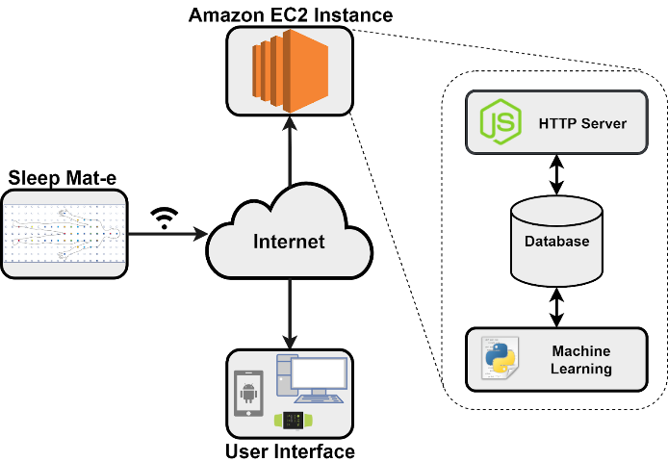

*Figure* *3*: System Architecture (System functionality encompassed)

The cloud is set up using Amazon Elastic Compute Cloud (Amazon EC2) web service that provides secure, re-sizable compute capacity in the cloud. The reason for selection is simple and user friendly web service interface that allows to obtain and configure capacity with minimal friction. Data received by the cloud server is then stored in a MySQL Server database. Our solution uses a central server design which performs the data storage, processing and user authentication. The server is written in NodeJS that provides Express framework that allows us to form the backbone of the server. In our case, the backbone of the server is defined when our server can Send and Receive data from clients. A request is made to the server using a (Representational State Transfer) REST API to the server.

A python script running on the server then reads the recently added data to the table in the Database for classification. We use machine learning algorithms to perform statistical analysis of the data obtained from the data acquisition unit and classify different posture. A python script runs continuously on server to receive and classify the data. We make use of the Google's popular deep learning library called TensorFlow. This library incorporates different APIs to build at scale deep learning architecture like CNN or RNN. The data is first loaded into the memory, a model is built and then machine learning algorithm is trained and the posture is estimated.

The Android application is provided to the end user (subject of health professional) to interact with the system and retrieve information from the cloud. The information provided is the current sleep posture and the statistical data for a specified period of the time. The statistical data contains the overall time in bed and the posture distribution over the time. The application also generates fall warning alert when the user is sleeping closer to the edge of the mat. The fall warning will help in preventing any potential fall injuries. If a user sleeps in one posture for a significant amount of time a bed sore alert generation option is also provided for the caregivers so that they can attend the patient and help change their posture. Bed unoccupied alert is generated when the user leaves the bed which is also helpful for the caregivers.

# Mat Construction

1. Sensor Design

Force sensitive resistors [sensors and actuators] are simple tactile sensors that are used in applications where changes and differences in pressure need to be detected. They could me made using conductive polymers, elastomers or semiconducting polymers, piezoresistive material, conductive wires, fibre-optical or fibre-gratting sensor. They are also termed piezo-resistive sensors, as the resistance is pressure dependent i.e., variation in conductivity of the sensor. In our research, we implement an array of FSR’s to capture the pressure distribution of a person’s sleeping posture. Furthermore, they are cheap as they involve low cost electronics and for these reason they are widely used in such applications. For the construction of the sensor material, Velostat pressure sensitive material was used. As Velostat is an inexpensive material it helped us by keeping the development costs low.

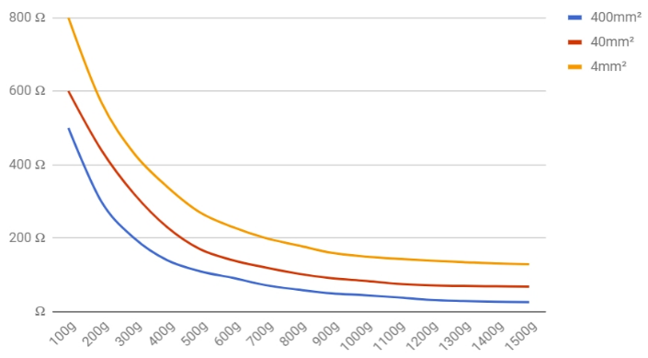

*Figure* *6*: Velostat Resistance vs Pressure Graph [13]

The FSRs constructed from Velostat have a resistance to pressure curve that can be modelled as an exponential decay curve. Within a small region of the pressure range, there is a significant drop in the resistance of the material which clearly shows the sensors are highly sensitive as seen in Fig. 6. This property helps us to distinguish between regions with high- or low-pressure values. An FSR sensor with the greater surface area has higher resistance, but it still has the same level of sensitivity. This is an important property as we can easily then have sensors designed for different pressure ranges with all of them having the same sensitivity. The square shaped sensor has dimensions of *2cm x 2cm* and contains three main layers which are a top electrode, Velostat, and bottom electrode, respectively. We expect areas of sensors that are in contact with bone such as shoulders or ankles to have a higher-pressure reading. From the preliminary testing, we discovered that the highest ADC values that we were able to obtain by forcefully pressing down on a sensor were not higher than 1000. The ADC used is of 10-bit resolution (0-1023). Recorded ADC values were always around 800 to 900 when sensors were forcefully pressed.



1. Mat-e Construction

Our Mat-e is designed using an array of sensors attached to a thin plastic film under the sheet, making it easy to deploy on the mattress and unobtrusive to sleepers. As shown in the left of Figure 5, a total of 171 sensors are placed in the 19x9 grid structure. The sensors are organized in rows and columns, forming an I-by-J rectangular matrix where denotes the pressure sensor at the row and column of the matrix, The total number of sensor is . Our current sleep mat has 171 pressure sensors. These sensors are in a configuration of 19 rows and 9 columns.



The dimensions of the Mat-e are the same as that of a single mattress i.e., 92x188 cm. The sensors are around 7.5 cm apart. We use the equally spaced sensor topology as opposed to a few other sensor topologies such as the placement of sensors depending on the regions on the mat expected to have certain pressure values. We prefer a sensor topology that is more generic and would fit all the different types of major and does not impose any restrictions on the user for the usability of the map.

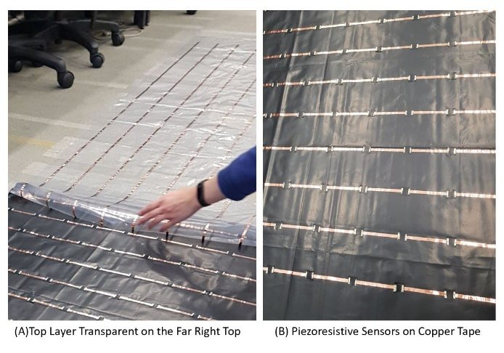

*Figure* *8*: Mat Construction

In Fig. 8. two different plastic layers can be seen, Copper tapes applied on the bottom black plastic layer (B) of the mat run perpendicular to the Copper tapes applied on the top transparent plastic layer (A). The Velostat sensor cutouts were placed on the copper tapes on the bottom plastic sheet that can be seen in Fig. 8 (B) as black dots along the entire stretch of each copper strip. Cost of the material for the mat was a major factor as we wanted our system to be affordable. The cost for Velostat was $5 and the copper tapes $30 per 20 m rolls. However, the cost for the copper tape can be lowered if we use copper tape of reduced width. The overall cost of the mat was around $50 which ensures that our solution is affordable.

1. Data Acquisition

The data acquisition circuit unit captures a snapshot of sensor mesh (the values of all the FSR’s on the mat at an instance) and sends it wirelessly to the cloud database. We use sensor matrix scanning strategy and this is done by pulling up one column the analogue values outputted by all the rows fed to ADC are captured by the controller. The same procedure is repeated for all the column, and pressure values of all nodes are captured. This is used to construct the snapshot of the pressure profile of the person at a given instance. This sets a requirement of 19 digital outputs and 9 analogue input channels and low end microcontrollers available in the market are not capable of meeting this requirement and others with higher IO count are expensive. We considered the option of using a multiplexer chip thus reducing the number of IOs required but multiplexers with 16 or more outputs per IC are expensive. The more economically feasible can using three eight-output multiplexers. This would require at least nine control pins from a microcontroller which were too many. We opted to deploy a shift registers in a daisy-chain configuration, which essentially creates a single large shift register while using the same common control signals for each chip. This requires only five control signal lines for any number of shift registers in a daisy-chain configuration. LSB asserted will shift and activate the column lines in sequential fashion. Eventually, each of the nine rows was connected to voltage divider circuit. The layout of our connections to and from the sensing mat is shown in Figure 9.

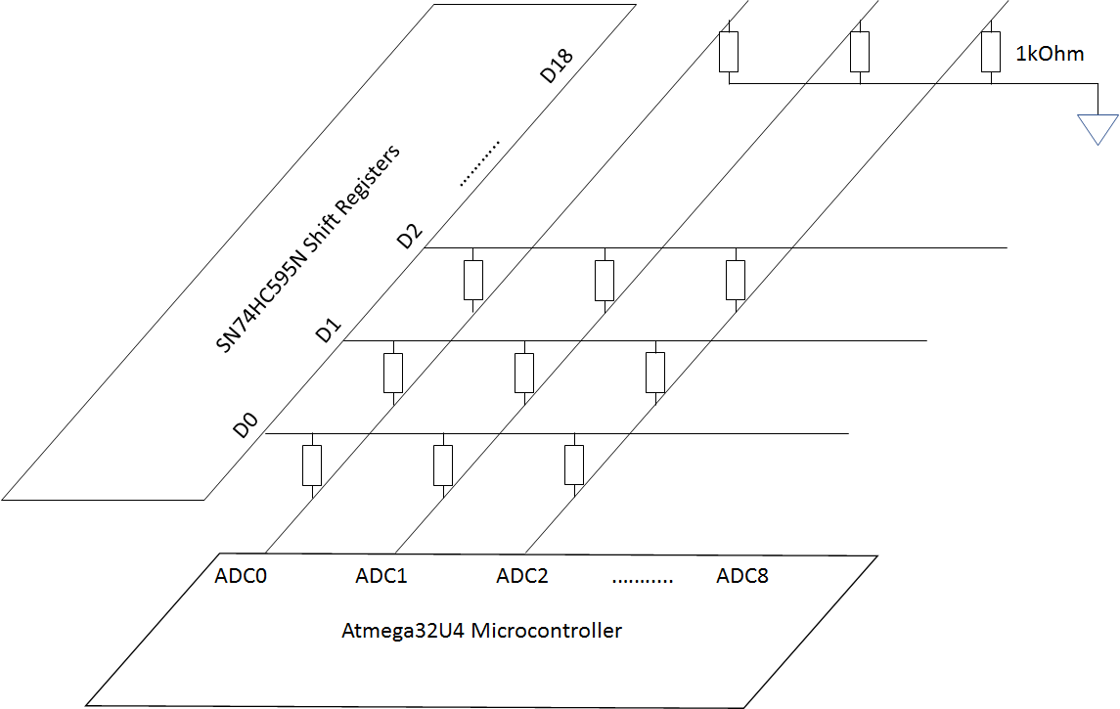

Figure 9: Layout of connections

A common eight output shift register, the Texas Instruments SN74HC595N [23] was chosen for our application. Out of five possible control pins, four were connected to the microcontroller and one was tied to ground, which was the output enable pin. This further reduced the I/O pin requirements for our microcontroller. Since we had tied output enable to ground, our shift register configuration could only produce high or low outputs. While one output is pulling high and the other pins are pulling low, we found that current was being sunk into pins that were pulling low. To rectify this issue, a 1N4148 diode [24] was placed at each shift register output to prevent current from flowing back into the pins. The use of a diode induced a forward voltage drop of 1V in the worst case, reducing the shift register output from 5V to 4V. This in turn reduced the effective range of our FSR’s. The maximum current for each shift register output was rated at 35mA [23]. In the worst case, with a 1kOhm fixed resistor, where all the FSR’s in a column were pressed at maximum pressure, the current drawn was calculated to be 35.1mA. The worst-case current draw could be further reduced by having a larger fixed resistor value in the voltage divider, which would again reduce the range of our ADC readings. However, it is highly unlikely that maximum pressure would be exerted on all the nodes of a single column at any given instance of time.

1. Prototype testing

The experimentation was divided into two parts. First a breadboard-based prototype was developed.

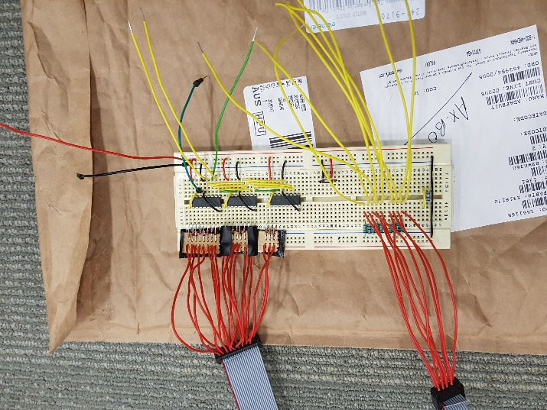

*Figure* *11*: Breadboard Testing of Sleep Mat

The Fig. 11 highlights the role of multiplexing in the design. The three shift registers in Fig. 11 can be seen in the top middle of the breadboard connected to the 19 red cables on the top left. The diodes for all the 19 rows are connected at the outputs of the shift registers. The 9 red cables at the bottom left are connected to the 9 ADC input channels. These input Channels were then connected to Arduino Leonardo development board using voltage dividers. Breadboard testing is a significant aspect in the development of design as it allowed us to verify our circuit schematic which was then finalized for PCB production.

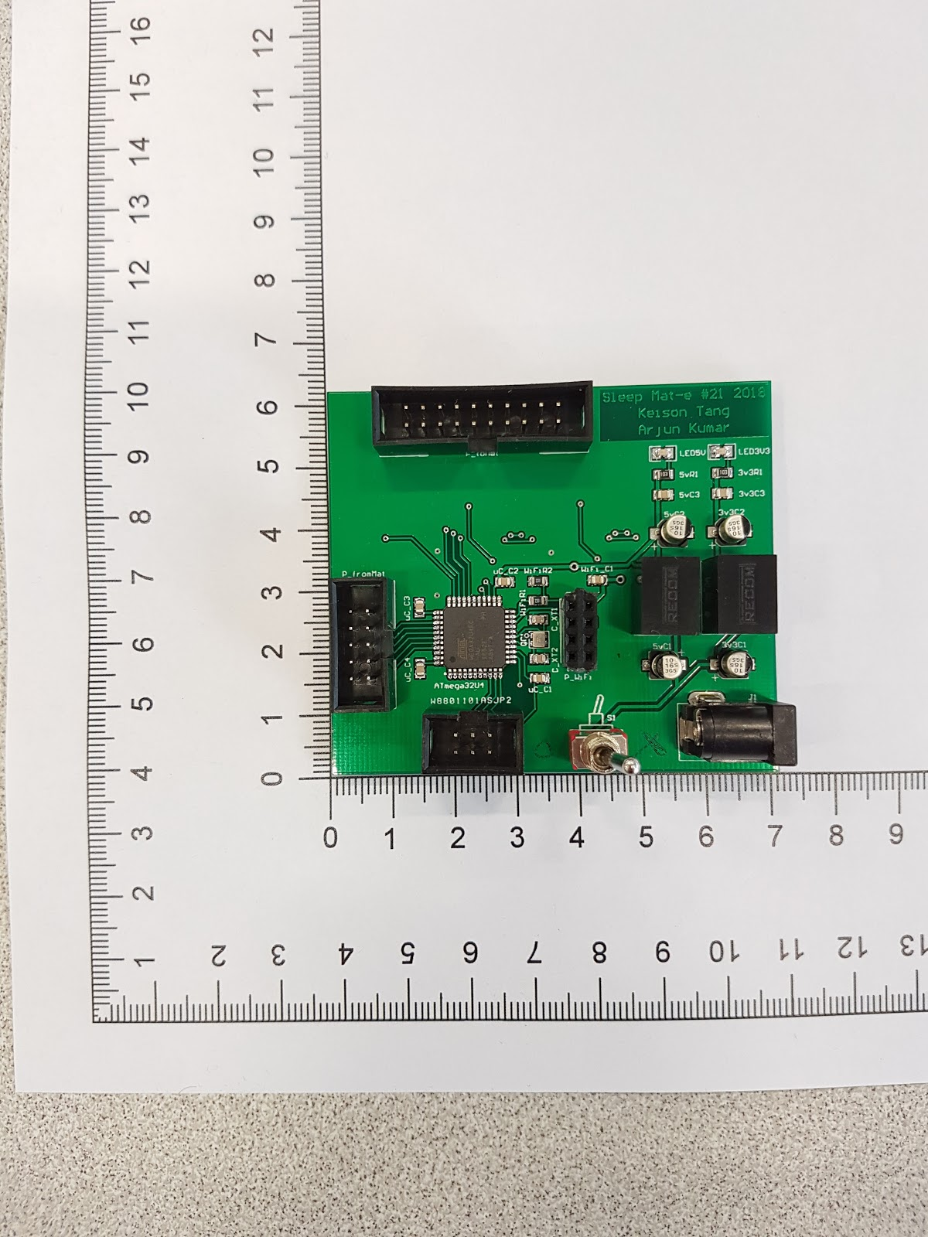

The final completed PCB in the Fig. 12 is 7 cm along the horizontal axis and 6.4cm along the vertical axis. The ATmega32u4 can be seen in the center of the PCB with two 5V regulators for a clean 5V supply on the right side. The Socket on the very top of the PCB is for the 5V connection to the 19 rows on the sleep mat which are activated by the shift registers. During the testing of the ADC channels connected to our designed PCB, it was noticed that there was noise on four consecutive ADC channels. However, the noise across the channels was consistent in magnitude. After some investigation, it was discovered that these pins were connected to JTAG debug and disabling JTAGEN fuse resolved the issue.

*Figure* *12*: Our Designed PCB

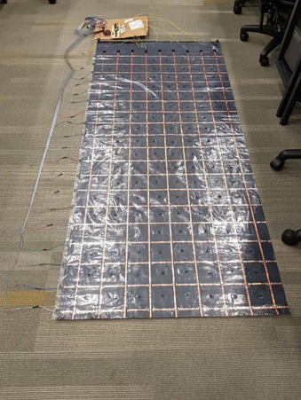

*Figure* *9*: Completed mat

Fig. 9 illustrates the completed mat with attached cables visible on the far left and the far top. The two plastic layers have been placed together to form a grid of sensors.

Diodes played a major role in the functioning of the sleep mat as they would stop current from flowing through the rows of copper tape that had been set to low by the microcontroller. The diodes were connected to the outputs of the shift registers to stop the current flowing into the grounded pins. The voltage scale regarding the ADC value was now from 0V to 4.3V as there was a 0.7V

# Posture Recognition

We identify six different cases based on positions a user could be in when on the mat. These positions are identified as “Face Up”, “Facedown”, “Right Lateral”, “Left Lateral”, “Unoccupied” and “Closer to the Edge” as shown in Fig. 5. The closer to the edge case will alert the caregiver through the Android application that someone is about to fall off the bed.

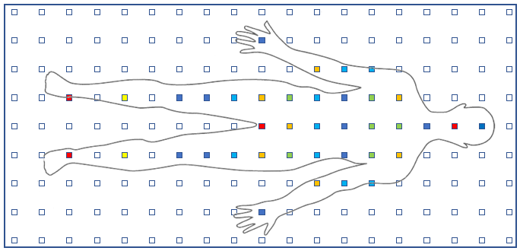

*Figure* *4*: Sensor Topology for Sleep Mat-e

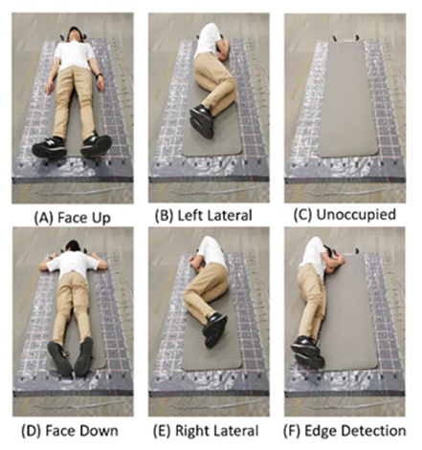

*Figure* *5*: The 6 different cases that are identified

*In the Fig. 4 these sensor materials can be seen as small squares equally distributed over the entire mat. The varying colours of the sensors in Fig. 4 are varying levels of pressure regions.*

The images shown in Fig. 14 have a colour range which is based on the magnitude of the pressure applied to the FSRs. The brighter colour (yellow) indicates the highest pressure. The python script is used for the classification of the data stored in the database by NodeJS. Libraries used in the python code are MySQL, TensorFlow, matplotlib and NumPy. MySQL library allows us to establish a connection with the database from python and then access the most recent data. APIs provided by TensorFlow library is used to start the TensorFlow session which is then used for classification of data. Matplotlib and NumPy are used for generating the categorical heat map images using a 2D array. A 2D array data structure is used for storing the values read from the MySQL query in the python script. These are the images shown in Fig. 14 that are used by the TensorFlow session for sleep posture prediction. A new piece of data is classified when the python script reads a flag set in a text file that is edited by NodeJS. This was to ensure that python script was not continuously polling the database. A method that allows us to start the python script from the NodeJS was also tested. However, it was found that it was not the optimal way of classifying data as the python script will restart every time and was not able to classify data in the given time because the restart of the script will also restart the TensorFlow session which creates a significant delay to start. Whenever the server updates the table with new data, the python script begins to classify it.

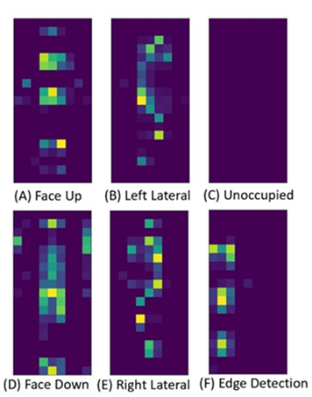

*Figure* *14*: Categorical heat map images generated from the pressure readings

This is an image recognition problem and deep learning, specifically Convolutional Neural Networks (CNN), is an effective tool so solve this problem. We make us of TensorFlow, an open source artificial intelligence library which uses data flow graphs to build models. More precisely, it is an image classifier, type of image recognition algorithm that takes an image (or part of an image) as an input and predicts what the image contains. The output is a class label which is one of the posture here. The dataset comprises 200 images for each of the six possible cases i.e. classes. Each image has three channels and all images have some aspect ratio. From the collected 200 images for each case, we filtered out the images that were either similar with other cases or were difficult to classify. This was due to the resolution of the mat.

Instead of creating whole model again, we retrain already created model with our own data. We adapt a pre-trained network for other classification based on TensorFlow Hub module that computes image feature vectors. By default, it uses the feature vectors computed by Inception V3 (CNN) trained on ImageNet. The training usually took around 10 to 15 minutes depending on the size of the data. Graph file generated from the training session was then transferred to the server and used in a TensorFlow session for classifying postures.

# Mobile Application

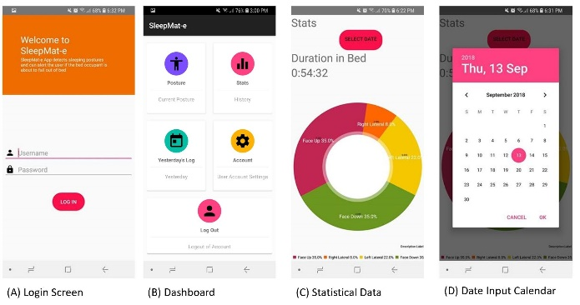The final stage of our solution was to display the processed data to the user using a smartphone. The Android application then provides the processed information to the end user. The information provided is the current sleep posture and the statistical data for a specified date. The statistical data contains the overall time in bed and the posture distribution. The application also generates fall warning alert when the user is sleeping closer to the edge of the mat. The fall warning will help in preventing any potential fall injuries. If a user sleeps in one posture for a significant amount of time a bed sore alert is generated for the caregiver so that they can attend the patient and help change their posture. Bed unoccupied alert is generated when the user leaves the bed which is also helpful for the caregivers.

Fig. 15 shows the screenshots of our Android app. The first screenshot is of the user login. The User Login screen also provides a general description of the application. Once a user has successfully logged in, the user can then access the dashboard (Fig. 15 (B)) from where the user can check the current status of the mat of whether someone is on the mat or not. “Posture” option when clicked uses cartoon images as an indication of the current posture the person is in as seen in Fig. 16. To get details regarding the sleep posture for a given night the user can select “Stats” option and then select a date through the calendar menu. The “Stats” option also provides information regarding how to overall time in bed. This time is measured from midday of the select date to the midday of the next day; this covers 24 hours, a complete day.

Edge Alert is triggered when the system detects that the user is close to either the left or the right edge of the mat which can be seen in Fig. 16 (F). When the user leaves the bed the “Bed Alert” is triggered for the caregiver. This notifies the caregiver that the bed occupant has left the bed. Both alerts are intended to inform the android application user about the possibility that the user may fall or has fallen out of bed.

*Figure* *7*: FSRs Voltage Divider

Our designed pressure mat has 171 sensors embedded in it. Acquisition of data from all these sensors had to be done by implementing multiplexing to read a row of sensors at a time. For example, to read the first row of sensors, we set every row except the first row to Logic low. Once all the other 18 rows have been grounded we then read the 9 columns (9 ADC channels) of the first row. After all the 9 sensor values have been read (9 columns), then a shift register is used to activate the next row and repeat the procedure. Our hardware utilises SN74HC595 8-Bit shift register for controlling the activation of 19 rows. Three shift registers are in a cascading topology to give a total of 24 control outputs of which 19 are utilized. Shift registers were preferred over the multiplexers because this design saved us one input select lines as a multiplexer for 24 channels would require five select lines. Also due to our design requiring us to read one row of sensors at a time and in sequential order, there was no requirement for a multiplexer, and at the same time, it was difficult to find a multiplexer that suited our application. This also simplified the design as we now only had to alternate between high and low logic on only one input select line of the shift register to activate the next row.

*Figure* *15*: Android App Screenshots

# Results

In this section, we will discuss the results that we obtained from testing our sleep mat. The developed prototype can identify four different postures namely “Face up”, “Face Down”, “Right Lateral” and “Left Lateral” alongside generating fall warning, bed sore alerts and whether the bed is occupied or not. Our system also has an android application which allows a user to get statistical data regarding their sleep. TensorFlow machine learning library is used for classification of the pressure images that are generated from the pressure sensors information sent by the microcontroller. The average accuracy of the system from the physical testing of the system after training the TensorFlow model was 90.4%.

*Figure* *16*: Current Posture & Fall Alert (Android App)

The system performed well for all the different cases with the highest for Unoccupied and Edge as these were cases that were easy to classify.

|  |  |
| --- | --- |
| Category | Accuracy (%) |
| Unoccupied | 100.0 |
| Face up | 92.5 |
| Face down | 90.0 |
| Left Lateral | 85.0 |
| Right Lateral | 80.0 |
| Edge | 95.0 |

TABLE 1

# Future Work

Further improvements can be made to the system to enhance the overall functionality. For example, increasing the resolution of the system by adding more

pressure sensors will allow us to generate pressure images with higher resolution which will make it easier for the TensorFlow to distinguish between different postures. This will also allow us to have more postures recognised. The cost will only increase slightly as the Velostat material is inexpensive and copper tape will be of reduced width ensuring the construction of the mat is affordable. Android application can be improved to provide more detailed statistical data such as posture distribution for every hour, weekly and monthly reports. During the testing, it was noticed that there is a possibility to detect respiration rate. ,Some pressure sensors were detecting the breathing rate as the ADC values were oscillating without the bed occupant changing posture. More sensitive sensors can be used for the region below the chest to detect breathing rate. However, this will require local signal processing as sending the data via the internet for processing will be slow and infeasible. Development of an Android or IOS application for smartwatch will make the system more flexible, and the health care professionals will be able to view statistical data and get alerts on their smartwatch.

# Conclusion

In this paper, we presented a system that is unobtrusive, affordable and accessible through a smartphone. Our system can identify 4 different major sleep postures alongside generating fall warning, pressure sore and unoccupied bed alerts. The cloud server is used for collection and processing of the sensor data. Machine learning is used for the classification. A user-friendly android application allows users to easily access the statistical data related to their sleep such as posture distribution and generates fall, bed sore and bed unoccupied alert warnings. The system has an average accuracy of 90.4% in identifying different cases.

# Acknowledgements

The student would like to thank his supervisor Dr. Muhammad Nadeem and his secondary supervisor Dr. Duleepa Thrimawithana. The students would also like to thank Lab Technician Mr Wai for providing guidance and support for the development of hardware.

# References

[Ref.1] Population projections overview, Stats NZ, 8 March 2017. [Online]. Available: http://archive.stats.govt.nz/browse_for_stats/population/estimates_and_projections/projections-overview/nat-pop-proj.aspx. [Accessed: 28 April 2018].

[Ref.2] Colten HR, Altevogt BM, Institute of Medicine (U.S.). Committee on Sleep Medicine and Research. Sleep disorders and sleep deprivation: an unmet public health problem. Washington, DC: Institute of Medicine, National Academies Press, 2006.

[Ref.3]

[Ref.4] Harvey R Colten, Bruce M Altevogt, and Institute of Medicine (US) Committee on Sleep Medicine and

Research. 2006. Sleep Disorders and Sleep Deprivation. National Academies Press (US).

http://doi.org/10.17226/11617

[Ref.5] Verhaert, Vincent, Bart Haex, Tom De Wilde, Daniel Berckmans, Marie Vandekerckhove, Johan Verbraecken, and Jos Vander Sloten. "Unobtrusive assessment of motor patterns during sleep based on mattress indentation measurements." IEEE Transactions on Information Technology in Biomedicine 15, no. 5 (2011): pp. 787-794.

[Ref.6] D. Seitz, N. Purandare, D. Conn, “Prevalence of psychiatric disorders among older adults in long-term care homes: A systematic review,” International Psychogeriatrics, vol. 22, no. 7, p.1025-1039, June 2010.

[Ref.7] R. Catto, “The case for investment in: A quality improvement programme to reduce pressure injuries in New Zealand,” KPMG Advisory, New Zealand. Report. 19 Nov. 2015.

[Ref.8] Ye, S., and Eum. S. 2017. Implement the system of the Position Change for Obstructive sleep apnea patient. Journal of the Korea Institute of Information and Communication Engineering. 21, 6 (Jun. 2017), 1231-1236.

[Ref.9] Tangtrakulwanich B, Kapkird A. Analyses of possible risk factors for subacromial impingement syndrome. World J

Orthop. 2012;3(1):5–9.

[Ref.10] Cheyne JA. Situational factors affecting sleep paralysis and associated hallucinations: position and timing effects. J Sleep Res. 2002;11(2):169–77.

[Ref.11] Johnson DA, Orr WC, Crawley JA, Traxler B, McCullough J, Brown KA, Roth T. Effect of esomeprazole on nighttime heartburn and sleep quality in patients with GERD: a randomized, placebo-controlled trial. Am J Gastroenterol.

2005;100(9):1914–22.

[Re.12] "Bed Sore Lawyers | Pressure Sores | Queens, Long Island & NYC", *Bed, Bedding, and Bedroom Decoration Ideas*, 2018. [Online]. Available: http://www.homedesigndll.pw/photo/22043/bed-sore-lawyers-pressure-sores-queens-long-island-nyc.jpg. [Accessed: 08- Oct- 2018].

[Re.13] "Living outside the norm: An analysis of people living in temporary and communal dwellings, 2013 Census", Archive.stats.govt.nz, 2018. [Online]. Available: http://archive.stats.govt.nz/Census/2013-census/profile-and-summary-reports/outside-norm/residential-old.aspx. [Accessed: 08- Oct- 2018].

[Re.14] Ministry of Health, “DHB spending on services for older people,” 13 July 2016. [Online]. Available: https://www.health.govt.nz/nz-healthstatistics/health-statistics-and-data-sets/olderpeoples-health-data-and-stats/dhb-spending- 7 services-older-people. [Accessed 08- Oct- 2018]

[Ref.15] "Residential care questions and answers", *Ministry of Health NZ*, 2018. [Online]. Available: https://www.health.govt.nz/our-work/life-stages/health-older-people/long-term-residential-care/residential-care-questions-and-answers. [Accessed: 08- Oct- 2018].

[Ref. 16] ACC, “Statistics on our claims,” 29 April 2017. [Online]. Available: https://www.acc.co.nz/aboutus/statistics/#injury-stats-nav. [Accessed 08- Oct- 2018]

[Ref. 17]

[Ref.18] Mayo Clinic, Polysomnography (sleep study). [Online]. Available: https://www.mayoclinic.org/tests-procedures/polysomnography/about/pac-20394877. [Accessed: 8 October 2018].

[Ref. 19] Itamar-medical, WatchPAT. [Online]. Available: https://www.itamar-medical.com/watchpat-home-sleep-testing-made-simple/. [Accessed: 8 October 2018].

[Ref. 20] Jun-ki Min, Afsaneh Doryab, Jason Wiese, Shahriyar Amini, John Zimmerman, and Jason I Hong. 2014. Toss “ N ” Turn : Smartphone as Sleep and Sleep Quality Detector. Proceedings of the 32nd annual ACM conference on Human factors in

computing systems - CHI ’14: 477–486. http://doi.org/10.1145/2556288.2557220

[Ref. 21] N. Pombo and N. M. Garcia, “ubiSleep: An ubiquitous sensor system for sleep monitoring,” 2016 IEEE 12th International Conference on Wireless and Mobile Computing, Networking and Communications (WiMob), 2016.

[Ref. 22] Google Play Store, “Sleep as Android: Sleep cycle tracker, smart alarm,” 2018. [Online]. Available: https://play.google.com/store/apps/details?id=com.urbandroid.sleep. [Accessed 28 April 2018].

[Ref.23] Google Play Store, “Runtastic Sleep Better: Sleep Cycle \& Smart Alarm,” 2018. [Online]. Available: https://play.google.com/store/apps/details? id=com.runtastic.android.sleepbetter.lite. [Accessed 28 April 2018].

[Ref. 24] T. Hao, G. Xing, and G. Zhou, “iSleep: unobtrusive sleep quality monitoring using smartphones,” in Proc. of ACM Sensys, 2013, pp. 4:1–

4:14.

[Ref. 25] Fitbit Inc., “Fitbit Charge 2,” 2018. [Online]. Available: https://www.fitbit.com/nz/charge2. [Accessed 28 April 2018].

[Ref. 26] Jawbone, “Up3,” 2018. [Online]. Available: https://jawbone.com/up/trackers/up3. [Accessed 28 April 2018].

[Ref.27] Jeon, L., and Joseph Finkelstein. "Consumer sleep tracking devices: a critical review." In Proc. Stud. Health Technol. Inform., vol. 210, pp. 458-460. 2015.

\bibitem{masek}

[Ref.28] Yu M, Rhuma A, Naqvi SM, Wang L, Chambers J. A posture recognition-based fall detection system for monitoring an elderly person in a smart home environment. IEEE Trans Inf Technol Biomed. 2012;16(6):1274–86.

[Ref.29] M. Masek, C. P. Lam, C. T. Fryer, B. Jansen, K. Baptist, “Sleep monitor: A tool for monitoring and categorical scoring of lying position using 3D camera data,”

[Ref.30] Bhatia S, Sigal L, Isard M, Black MJ. 3D human limb detection using space carving and multi-view eigen models. In: 2004 IEEE conference on computer vision and pattern recognition workshop (CVPRW’04). IEEE; 2004.

[Ref.31] T. Grimm, M. Martinez, A. Benz, and R. Stiefelhagen, “Sleep position classification from a depth camera using bed aligned maps,” in Proc. IEEE Int. Conf. Pattern Recog., 2016, pp. 319–324.

[Ref.32] J. Lee, M. Hong, and S. Ryu, “Sleep monitoring system using kinect

sensor,” International Journal of Distributed Sensor Networks, 2015.

[Ref.33] C. Torres, V. Fragoso, S. Hammond, J. Fried, and B. Manjunath, “Eye-CU: Sleep Pose Classification for Healthcare using Multimodal Multiview Data,” in Winter Conference on Applications of Computer

Vision (WACV), 2016.

[Ref.34] M. Martinez, B. Schauerte, R. Stiefelhagen, International Conference on Computer Analysis of Images and Patterns, pp. 465-472, 2013.

[Ref.35] M. Martinez, L. Rybok, R. Stiefelhagen, "Action recognition in bed using bams for assisted living and elderly care", Machine Vision Applications (MVA) 2015 14th IAPR International Conference on, pp. 329-332, 2015.

[Ref.36] E. Hoque, R. F. Dickerson, and J. A. Stankovic, ‘‘Monitoring body positions and movements during sleep using WISPs,’’ in Proc. Wireless Health,

2010, pp. 44–53.

[Ref.37] J. Park, W. Nam, J. Choi, T. Kim, D. Yoon, S. Lee, J. Paek, and J. Ko, ‘‘Glasses for the third eye: Improving the quality of clinical data analysis with motion sensor-based data filtering,’’ in Proc. 15th Conf. Embedded Netw. Sensor Syst., 2017, p. 8.

[Ref.38] X. Liu, J. Cao, S. Tang, and J. Wen, ‘‘Wi-sleep: Contactless sleep monitoring via WiFi signals,’’ in Proc. IEEE Real-Time Syst. Symp., Dec. 2014,

pp. 346–355.

[Ref.39]Liu, J., Chen, X., Chen, S., Liu, X., Wang, Y., & Chen, L. (2019, April). TagSheet: Sleeping Posture Recognition with an Unobtrusive Passive Tag Matrix. In IEEE INFOCOM 2019-IEEE Conference on Computer Communications (pp. 874-882). IEEE

[Ref.40] Zhang, F., Wu, C., Wang, B., Wu, M., Bugos, D., Zhang, H., & Liu, K. R. (2019). Smars: sleep monitoring via ambient radio signals. IEEE Transactions on Mobile Computing.

[Ref.41] Lin, F., Zhuang, Y., Song, C., Wang, A., Li, Y., Gu, C., & Xu, W. (2016). SleepSense: A noncontact and cost-effective sleep monitoring system. IEEE transactions on biomedical circuits and systems, 11(1), 189-202.

[Ref.42] Toms M (2000) Patient movement detection. URL https://www.google.com/patents/US6036660, uS Patent 6,036,660

[Ref.43] Alaziz M, Jia Z, Liu J, Howard R, Chen Y, Zhang Y (2016) Motion scale: A body motion monitoring system using bed-mounted wireless load cells. In: 2016 IEEE First International Conference on Connected Health: Applications, Systems and Engineering Technologies (CHASE), pp 183–192, DOI 10.1109/CHASE.2016.13

[Ref.44] J. J. Liu, W. Xu, M.-C. Huang, N. Alshurafa, M. Sarrafzadeh, N. Raut, and B. Yadegar, “A dense pressure sensitive bedsheet design for unobtrusive

sleep posture monitoring,” in Proc. IEEE Int. Conf. Pervasive Computing and Communications, 2013, pp. 207–215.

[Ref.45] S. Lokavee, N. Watthanawisuth, J. P. Mensing, and T. Kerdcharoen, “Sensor pillow system: Monitoring cardio-respiratory and posture movements during sleep,” in Proceedings of the 4th Biomedical Engineering International Conference, BMEiCON-2011, pp. 71–75,Thailand, January 2012.

[Ref.46] E. J. Pino, A. Dorner de la Paz, P. Aqueveque, J. A. Chavez, and A. A. Moran, “Contact pressure monitoring device for sleep studies,” in Proceedings of the 35th Annual International Conference of the IEEE Engineering in Medicine and Biology Society (EMBC), pp. 4160–4163, Osaka, Japan, July 2013.

[Ref.47] L. Lin, Y. N. Xie, S. H. Wang et al., “Triboelectric active sensor array for self-powered static and dynamic pressure detection and tactile imaging,” ACS Nano, vol. 7, no. 9, pp. 8266–8274, 2013.

[Ref.48] S. Bennett, Zhaofen Ren, R. Goubran, K. Rockwood and F. Knoefel, "In-Bed Mobility Monitoring Using Pressure Sensors", *IEEE Transactions on Instrumentation and Measurement*, vol. 64, no. 8, pp. 2110-2120, 2015.

[Ref.49] M. B. Pouyan, J. Birjandtalab, M. Heydarzadeh, M. Nourani, and S. Ostadabbas, “A pressure map dataset for posture and subject analytics,” *2017 IEEE EMBS International Conference on Biomedical & Health Informatics (BHI)*, 2017.

[Ref.50] S. Ostadabbas, M. B. Pouyan, M. Nourani, and N. Kehtarnavaz, “In-bed posture classification and limb identification,” *2014 IEEE Biomedical Circuits and Systems Conference (BioCAS) Proceedings*, 2014.

[6]"Sleep deprivation: A cause of high blood pressure?", *Mayo Clinic*, 2018. [Online]. Available: https://www.mayoclinic.org/diseases-conditions/high-blood-pressure/expert-answers/sleep-deprivation/faq-20057959. [Accessed: 08- Oct- 2018].

[1]"Population ageing in New Zealand", *Archive.stats.govt.nz*, 2018. [Online]. Available: http://archive.stats.govt.nz/browse_for_stats/people_and_communities/older_people/pop-ageing-in-nz.aspx. [Accessed: 08- Oct- 2018].

[2] "Living outside the norm: An analysis of people living in temporary and communal dwellings, 2013 Census", *Archive.stats.govt.nz*, 2018. [Online]. Available: http://archive.stats.govt.nz/Census/2013-census/profile-and-summary-reports/outside-norm/residential-old.aspx. [Accessed: 08- Oct- 2018].

[3] Ministry of Health, “DHB spending on services for older people,” 13 July 2016. [Online]. Available: https://www.health.govt.nz/nz-healthstatistics/health-statistics-and-data-sets/olderpeoples-health-data-and-stats/dhb-spending- 7 services-older-people. [Accessed 08- Oct- 2018]

[8] "Number of smartphone users worldwide 2014-2020 | Statista", *Statista*, 2018. [Online]. Available: https://www.statista.com/statistics/330695/number-of-smartphone-users-worldwide/. [Accessed: 08- Oct- 2018].

[12] N. Pombo and N. M. Garcia, “ubiSleep: An ubiquitous sensor system for sleep monitoring,” *2016 IEEE 12th International Conference on Wireless and Mobile Computing, Networking and Communications (WiMob)*, 2016.

[13]*Reps.cc*, 2018. [Online]. Available: https://reps.cc/wp-content/uploads/2017/12/Clipboard01-1.jpg. [Accessed: 08- Oct- 2018].

[14]*Ww1.microchip.com*, 2018. [Online]. Available: http://ww1.microchip.com/downloads/en/DeviceDoc/Atmel-7766-8-bit-AVR-ATmega16U4-32U4_Datasheet.pdf. [Accessed: 08- Oct- 2018].

\bibitem{nzgovtreport1}

"Population ageing in New Zealand", Archive.stats.govt.nz, 2018. [Online]. Available:http://archive.stats.govt.nz/browse\_for \_stats/people \_and \_ communities/older\_ people/pop \- ageing-in-nz.aspx. [Accessed: 08- Oct- 2018].

\bibitem{huang}

[22] W. Huang, A. A. P. Wai, S. F. Foo, J. Biswas, C.-C. Hsia, and

K. Liou, “Multimodal sleeping posture classification,” in International

Conference on Pattern Recognition (ICPR), 2010.

{sensors and actuators}

N. Ida, Sensors, Actuators, and their Interfaces: A Multidisciplinary Introduction. Edison, NJ: SciTech Publishing, 2014.